Planning a Computing Project

**Technical Report Tourstify**

Raneem Sa’deh 22210016

horizontal line

# 

# Introduction

Big data, often referred to as the intellectual petroleum of our time, permeates all sectors of life. In recent years, the flow of data traffic has led to a heavy focus on the concept of big data. And according to recent research, the big data market has expected to reach $229.4 bilion in 2025 (Deepa et al., 2022). Big datas have become a cmcial topic in large scientific and engineering fields, such as computer vision, the Internet of Things (IoT), and data analytics. Progressions in communication and information technologies and Industry 4.0 have driven industries toward greater automation, emphasizing the importance of big data (IEEE Xplore Full-Text PDF: no date b).

To manage and utilize the vast amounts of data generated every second, organizations employ various tools and technologies, such as IoT, computer vision, machine learning, and data mining algorithms. These tools enable organizations to glean valuable insights from operational data, including transaction prices, electricity sales, energy consumption, and customer information. For instance, Building Automation and Management Systems

(BAMSs) integrate hardware and software to connect HVAC, lighting, security, and other

systems, promoting energy efficiency, optimizing water consumption, enhancing safety, and reducing maintenance costs (Ippolito et al., 2014; Su & Wang, 2020). The advent of ICTs, cloud computing, and big data analytics has revolutionized BAMSs enabling vast data collection and advanced analysis et al., 2020; Himeur et al.). Al-based analytics

further enhance BAMSs by predicting building occupancy, forecasting thermal comfort, and enabling demand-side response, among other benefits (Himeur et al., 2020; O'Grady et al., 2021).

Despite these advancement's, there are challenges and opportunities associated with Big Datas' 6 Vs'—Volume, Velocity, Variety, Veracity, Value, and Variability. In the energy

sector, for instance, big data applications have evolved significantly. A 2012 survey revealed that 70% of US oil companies were indifferent to applying big data techniques (Joost Hoozemans., 2021; FPGA Acceleration for Big Data Analytics). However, a more recent survey by General Electric and Accenture indicated that 81% of oil and gas companies now prioritize big data (Joost Hoozemans., 2021; FPGA Acceleration for Big Data Analytics). This shift highlights the opportunities big data presents in energy conservation, management, and environmental protection.

### Big Data In Toursim

In the field that I have chosed which is travel and tourism, for a company like Tourstify that focuses on solo travelers, big data can be a helpful asset.

When the company analyze huge amount of data from the previous travelers like there preferences, interactions, and the travel time they prefer. All these can help the company to offer highly personalized recommendations, such as suggesting schedules, journeys, and local experiences that align with a traveler’s unique interests and past behaviors. And if that was in real time it would be amazing for example to suggest new plan according to the weather or transportation delays. Using machine learning model with these data can help in predicting common issues and offering solutions early.

For Tourstify, leveraging big data not only enhances the individual travel experience but also drives operational efficiency, innovation, and sustainable practices, aligning with the company’s mission to provide authentic and meaningful travel experiences. In my research on Tourstify, I will explore how the company leverages big data technologies to enhance its services and operations. Tourstifys focus on continuous innovation, and commitment to authentic travel experiences, and fostering a global commu’nity of connected travelers provides a rich context for understanding the practical applications of big data in the travel industry. My technical report is going to study the impact of the big data by conducting researc at Tourstify to understand the challenges and opportunities presented by Big Data's 6 V 's.

# 2 Organizational Study

### 2.1 Identify the organization

Because I want to select an organization for my project: I reseuched various compantes that operate in the tourism and travel sector, focusing on those that heavily utilize big data technologies. I aimed to find an organization that not only uses big data but also aligns with the innovative and inclusive spirit required for a successful case study. After shortlisting a few potential organizations, I reached out to them to discuss the possibility of collaborating on this project. I contacted Tourstify, an innovative travel company. Below is the text of the message I sent to the AI Engineering team member, Zakaria, on WhatsApp:

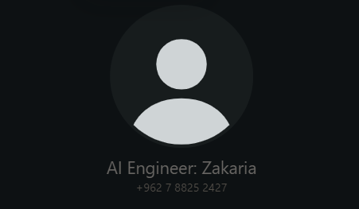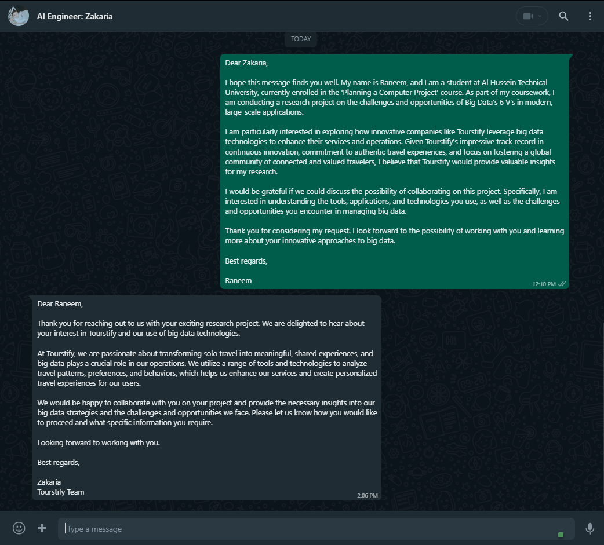

### 2.2 Features and the operational areas of the selected organization

Tourstify focused on transforming single travel into meaningful, shared experiences through the use of big data technologies.

And here are the key operational areas that support Tourstify's purpose:

|  |  |
| --- | --- |
| Research and development | Tourstifuy always focus on developing the algorithms to match the travelers with similar interests and optimizing travel recommendations based on user behavior and preferences, and this will help the solo travellers to enjoy there trip. |
| Marketing | by using big data analytics, it tailors marketing campaigns for the specific demographics, understanding traveler behaviors and preferences to create more effective campaigns, and they will feel that the promotions are personalized for them. And by understanding feeling in the customers comments this will help them to position their services in a competitive landscape. |
| HR | in this department the officials must focuse on managing all people-related aspects within an organization. This includes recruiting and hiring and onboarding, administering compensation and benefits, analyzing performance, and resolving employee conflicts. HR also make sure that legal compliance and maintains employee records' and promotes a safe and inclusive work environment. The department plays a vital role in supporting the organizational structure and advocating for employes with team members often specializing in payroll, benefits, or training. |
| Finance | in the finance department the officials are responsible for maintaining accurate financial records, analyzing financial activities, preparing budgets and forecasts, managing operational systems, and establieshing internal controls to prevent errors and fraud. Key roles within the department include accountants, auditors, budget analysts and finance controllers and also payroll officers and treasury analysts. Essential skills for working in finance include problem-solving and communication and analytical thinking and attention to detail and persuasiveness. |
| Customer Service | By collecting user comment’s and feedback on the platform, the company leverages this big data to improve customer service and user experience over time. |
| IT | An IT department employees must manage and maintain the company’ technology infrastructure, and providing technical support, programming, and website management. and their work also must include maintaining computer systems' and assisting users and updating software and making sure about compliance, overseeing data storage, and managing IT assets. The team also installs and repairs hardware and also develops business applications, manages databases, and maintains the company website, ensuring usability and network functionality. |

Stakeholders

* Internal

|  |  |
| --- | --- |
| Management | Responsible for critical decisions, and making sure that the organisation of big data initiatives aligns with the companys' mision of transforming solo travel. |
| Employees | They are responsible for carrying out the work assigned to them from developing the system and innovating and operating the platform, and they may participate in suggesting ideas to the officials if they find more useful aspects. |
| Shareholders | They are interested in the financial performance of the company -Tourstify-, influenced by how effectively the company utilizes big data to drive growth, and agonistically prefer to be the best in the market. |

* External

|  |  |
| --- | --- |
| Customers | They are going to use the personalized travel experiences, and by using the system they will provide new data that could be used in the models. |
| Suppliers | They should help in providing necessary data, technology, and services that support Tourstifys operations' by using data analytics tools and cloud services. |
| Government Agencies | They are the regulatory parties that must make sure the company complies with data protection laws and travel industry regulations. |
| Communities | They could be the local or the global or both communities affected by Tourstify services and commitment to responsible travel practices driven by data insights. |

### 2.3 Stakeholders

* Internal

**Management**: They play a very important role by putting strategic direction of the company, and they must make key decisions related to the adoption and implementation of big data technologies, driving the companys mission to transform solo travel into meaningful, shared experiences.

Their plans in how to use the best fit big data models to be consistent with the company's objectives, they must always encourage their employees, as the employee’s psychology affects the results.

**Employees**: The bigest role in the success of projects falls on the employees, as all departments from human resources, finance, marketing, IT and more are responsible for completing their tasks in the best possible way. those employees who are welltrained, motivated and aligned with the companys' mission are more likely to innovate and optimize processes, leading to improved decision making and better customer experiences, and their cooperation with other departments is esential to ensure that tasks are carried out effectively, which drives the company towards its goals.

* IT support: They maintains the companys' tech infrastructure, and making sure about the smooth operation of big data platforms and AI systems. They troubleshoot issues, manage updates, and assist other employees with tech problems.
* Marketing team: This team promotes Tourstifys' solo travel experiences using insights from big data analytics. They create targeted promotes, manage social media, and partner with travel famous influencers to increase brand awareness and attract new users.
* Security for the building: They manages physical access to Tourstifys' premises, protecting sensitive data and hardware. They control entry, monitor surveillance, and conduct regular security checks to safeguard the companys' assets.
* Cyber security expert: While those protect Tourstifys' digital assets and user data from threats. They implement security measures, conduct audits, and make sure with compliance with data protection regulations, maintaining user trust and company reputation.

**Shareholders:** They are the main stakeholders who effects the companys’ direction through their investment and roles. Their impact is through the allocation of resources and what they expect to return on investment, which shape the companys’ strategic decisions with big data technologies. They expect the company to use big data to boost their profits, market health and long-term growth, and in turn they need to ensure that management is implementing effective strategies that will achieve Touristify’s financial goals.

In order to guarantee that the company's big data initiatives are in line with larger societal values and safeguard the companys' reputation while promoting sustainable growth, theycan also advocate for ethical considertions and responsible data use.

* External

**Customers**: In any business on earth, in order to make a profit or benefit from the project, there must be users for your project, whether it is a product, service, or even an application. Customers are the primary external stakeholders, and the company's business usually affects them before anyone else. If the company provides a good product that customers love and desire, this will positively affect external stakeholders. This helps build customer trust and increases the likelihood of customers referring the brand to friends and family, thus increasing the company's sales and brand awareness.

The satisfaction and loyalty of customers are very important to Tourstifys' success. Their feedback and how they use the product gives valuable insights that help improve the product and services. Focusing on what the customers need and prefer, using big data, is really important for staying ahead of the competition and reaching the companys' goals.

**Communities**: The community around a business is a important external stakeholder because the companys' activities can affect it really. When a company donates to shelters or sponsors food drives, it shows it cares about more then just profit and builds trust and loyality with both customers and community members.

Tourstifys' commitment to giving back through sustainable travel initiatives help build a positive brand image and strengthen relationship with the community.

Engaging with local economies also boost social responsibility, which can increase customer loyality. On the other hand, government agencies play a key role in regulating the travel industry and enforcing data protection laws that Tourstify must follow. Compliance with these regulations are crucial to avoid legal issues, maintain the companys' reputation, and build customer trust. This includes following rules on taxes, the environment and worker safety, which impacts everyone involved in the business.

**Suppliers**: In the business field, a supplier is someone who provides first-class resources at lower costs than the market, which will reduce the budget for these materials, and then the company processes them and converts them into a final product to sell in the market.

In Tourstifys', suppliers provide the necessary technology and analysis tools that will serve the company, they can provide the company with the big data they need in their models to work best.

Suppliers must be worthy of the trust that the company gives them, to provide high-quality products and services, as strong partnerships with suppliers help ensure that the company has the latest technology, which is very important to maintain its position in the market.

**Government Agencies:** The government is able to regulate travel and enforce laws that Tourstifys' must follow regarding data protection and privacy. When the company complies with the government’s laws and does not get infringed, this will help it avoid legal problems and build trust with customers, which will help in the sustainability of the company’s success.

The government also have a great impact in helping the project succeed by financing it and helping to spread it, because the tourism project will bring benefits to the government in general.

### 2.4 Challenges to the success of the organization's business

* *Change management, including planned changes such as expansion, diversification, changes in legislation, and system upgrades.*

Tourstifys' may decide to grow and diversify its offerings, these changes need to be planned in advance, taking into account that they can be implemented without affecting the company's business.

It can be challenging to manage to expand into a new market and provide new services while maintaining the quality and offerings of the current ones, and may require a system upgrade and careful implementation to avoid disruption, for example, it is possible to use the *Phased Changeover method*, where both systems operate simultaneously and parts of the old system are gradually replaced by the new one.

However, if the management of this change is not successful, it will lead to operational inefficiencies, decreased customer satisfaction and increased costs. Balancing innovation with stability is crucial to maintaining a company's competitive advantage.

The travel field might also face many regulations like data protection laws, environmental standards, and safety rules, and adapting to these changing laws can be complicated and expensive. Not following legal requirements can lead to fines, legal problems, and harm to the companys' reputation. Its crucial for tourstify to stay updated with new laws and make sure all parts of the business comply to ensure its sustainability and success.

* *Legislation and industry standards relevant to the organization.*

Tourstify must follow industry standard’s and regulations like the GDPR -General Data Protection Regulation- for data privacy, which is very important because the company relies a lot on big data analytics. Also, sustainability rules and travel industry standards’ must be takem. Compliance isnot just about legal stuff but also keeping customer trust in the industry. So if Tourstify fails to meet these standards, it could face penalties and lose business.

* *Communication of the need for change to stakeholders.*

The reason behind changes like system upgrades or new services to all stakeholders is communicating which is really important. If theres' miscommunication, it can cause misunderstanding with employees and customers and other stakeholders. Clear and transparent communication is needed to get everyone on board, decrese the resistance, and make sure the transition goes smoothly. But if the communication is not good enough, it can lead to confusion and lower morale and even disrupt services.

* *Management of stakeholders before during and after change, such as training, target setting, and support.*

Making sure stakeholders, especially employees, get the right training and support during changing is very important. Setting clear targets and giving ongoing support help manage expectations and reduces mistakes. Iif stakeholder engagement is handled good it can lead to successful change, but if its not managed well, it can cause less productivity, dissatisfaction, and more and more turnover rates. continuous training and support are crucial for keeping positive outcomes after changes happen.

* *Method of implementation of change (project).*

The challenge of making changes, especially when it involves big data and tech upgrades needs a well structured and managed aproach. The real challenge is picking the right project management methods and tools to make sure is everything is done on time and works good. good project management means changes happens on time and stay in budget and reach the goals. But bad project management can cause delayes and cost tooo much and not get the benefits that were supposed to come from the change.

And there is three main methides that we can use in changing:

1. **Parallel Running**

* If it wants to upgrade it's CRM system to a more advanced platform that uses big data analytics for personalized marketing. To make sure the transition goes smooth and stay away from disruptions in customer service, the company plans to run both the old and new CRM systems together for three months. Well during this time, customer data is processed by both systems, and the customer service team gets trained on the new platform while still using the old one. This is going to help the company to compare outputs, find and fix any issues that might be foundin the new system, and make sure everything is working before throuing away the old system.

1. **Direct Changover**

* In this method the company might made a new mobile app to make solo travel better by giving real-time tips and connecting travelers with similar interests. They plan to launch the new app by completely replacing the old one on a set date. All the user data from the old app will be moved to the new one and the old app will be stopped right away. but how to make sure that there will not be risks? by doing a lot of testing and geting user feedback during development and they have a full support plan ready to fix any problems that come up after the launch**.**

1. **Phased Changeover**

* As I mentioned up,it is possible to use the Phased Changeover method, where both systems operate simultaneously and parts of the old system are gradually replaced by the new one, thes will help in lowering the chances of big disruptions.

***Real-World Examples***

*When Airbnb decide to update its system they aimed to make upgrades seamless and routine, so this change wont effect the system or the customers and users for the system this much, the effects will be lower from updating the whole system in one time, and this was a use of the Phased Changeover method.*

### 2.5 Business Requirements

Tourstify should build a smart system that can gather and understand travelers' likes and habits, using AI to suggest special travel plans and connect solo travelers with similar interests. but the system must scale smoothly as more users join, without slowing down or crashing, while keeping all users' information safe and private. The website should be easy to use on any device, and we need tools to monitor performance and train employees on the new technology. Success will be measured by how well the system matches travelers, maintains speed, and protects data, along with user feedback on ease of use and employee training completion, as well as the accuracy we get from the AI code. We aim to have the system fully operational within 12 months, starting with AI development, then focusing on website design, scalability, security, and final testing. This project is realistic because we have a skilled team and the determination to see it through, making solo travel more enjoyable and helping Tourstify grow as a business.

# 3 Research Study

### 3.1 Research Overview

### Qualitative & Quantitative

|  |  |  |
| --- | --- | --- |
|  |  |  |
| Focus | Understanding and exploring ideas and formulating. | To test the concepts, theories, or hypotheses |
| Analysis | To summarize, categorize, and interpret | Using math and statistical analysiss |
| Expressed in | Using the words | Using graphs and tables and numbers and maybe a few words |
| Sample | Few respondents | Many respondents |
| Questions | They are Open-ended Q | They are Close-ended or multiple choice Q |
| Characterized by | To understand, context, complexity, and subjectivity | To test, measure, objectivity,  replicability |

**Methods for collecting data -Quantitative-**

Surveys → To put several closed or multiple-choice questions distributed to a sample via various means, such as online or in person or over the phone.

Here is an example:

<https://forms.gle/DsNLRi84HmJHcm3M7>

Experiments → wherre there is a scenario where different variables are controlled and manipulated to determine cause-and-effect relationships.

Observations → To watch subjects in their natural setting, where controlling variables is not possible.

**Methods for collecting data -Qualitative-**

Interviews → To conclude verbal, open--ended questioning with respondents'.

Focus groups → To facilitate a discussion among a group of individual's on a specific topic to geather opinions for further research.

Ethnography → To immerse oneself in a community or organization for an extended period to observe its culture behavior closely.

Literature review → To review published works by other author's to gather releavant information.

***Interview Questions and Answers Transcript***

**Hello:**

Hello, Zakaria. Hello, Raneem. How are you doing? I'm fine. Today, I'm going to ask you some questions about how tdo Tourstify use big data.

Are you ready? Yeah. I'm fine with that.

**Q1:**

How does Tourstify's utilize big data to personalize travel experience for solo travelers? Now regarding big data, Tourstify already uses open source models which is already trained on big data available online.

These models are trained on text data which is NLP and the model is used with the name of a girl which is Heba in the application. Heba collects data from the user by asking him questions and following and after collecting the data, Heba can start giving the user a personalized experience on how to travel, where to travel, what to bring with the user in his experience on traveling.

So Heba is a feature or a service that you develop based on the insights gained from big data? Yeah, sure. That's how Heba is built.

**Q2:**

In what ways does Tourstify's ensure the scalability of its big data infrastructure as the company grows? Now regarding the data, our company is currently in the startup phase, So the data that we are collecting is not that big. And because of that, the database that the data is stored in or the server is not, is not filled with with enough information or enough data. But in case the server was filled with the data, we are going to find another way just such such as buying another server or updating the the the normal or the original server to a better one, which can cover a bigger data. By the way, this was a smart way to solve that problem.

Yeah. Of course. Some companies, solve this problem by another way of solution, which is not really cost efficient for our startup, which is buying a server and put it in the company. This is a very bad idea for for businesses, except if the business is really big and have, have have the required budget to buy the room and the the and to fix the temperature of the room and prepare the safety and security that can save the data and the database. But for our problem, as I said, we use rented servers online, which is, for now, is a good solution for our problem.

**Q3:**

What strategies does Tourstify's employ to maintain the privacy and security of large volumes of data it handles? Now regarding our data, as I said, we use rented servers to store our data, which is their problem to solve this problem, which is saving the data from being hacked or being stolen or being destroyed. So as an example, we use AWS servers. These servers already or the company which, which manages the these servers, which is from Amazon, already provides the required, security to save the data.

**Q4:**

What role does predictive analytics play in Tourstify's approach to enhance the travel experience? Now in Tourstify's , we collect information, previous information of traveler experience. And through this information such as such as information about where the traveler is going to travel or where is he at right now or, is he traveling alone or with somebody, this information or data is being used to hope the AI predicts or give the user a more personalized experience or an experience that fits his, intentions more.

**Idea/Ending:**

According to the information you provide about Tourstify, I think that Tourstify should build a smart system that can gather and understand the traveler's habits, likes, and using an AI to suggest special travel plans and connect solo travelers with similar interests with each other. That can make the traveling more fun.

That's an amazing idea, Raneem. Thank you very much. I will consider telling the idea for our CEO. You're welcome. Thank you Zakaria for being with us today.

**Using *purposive sampling technique* in my research:**

Here this type of sampling, might be known as judgment sampling, concern the researcher to use their expertise to select a sample that is the most useful and have knowledge in the field I making research in.

I have use it because it is often used to interview in qualitative research, where the researcher wants to take detailed knowledge about a specific thing rather than make statistical inferences, or where the employees in the company that have the knowledge are very small. An effective purposive sample must have clear criteria and a rationale for inclusion.

For example, when I want to make a research about computer vision and how the data is collected and then annotated I should search for a professional in AI at the company so he will give me the best answers I need, as I did in Tourstify because I’m making research in the field of big data so the best person to interview was the AI engineer.

### Ethical Considerations

* Before the interview, to avoid any problems, I will explain to the person I will interview how to film, record audio, take notes, and use the data and information I will collect.
* I will make sure that he agrees to participate in the interview and share his information so that I can benefit from it in my research, and he can withdraw at any time.
* After explaining the questions that will be asked, and that the interview will be recorded with audio and video, the AI ​​engineer *refused to record a video of the interview*, and only allowed an audio recording of the interview. He had no problem with his name and position in the company being mentioned, as for the data that I will record or notes, they will be stored securely to protect the candidate's privacy and he can review the information after the interview to confirm it.
* If he encounters any question that he does not want to answer, *he can decline it immediately*.
* When the interview date was agreed upon, an important work for the AI ​​engineer arose, which forced us to postpone the interview several times.
* Some informations in the interview was mentioned but *Zakaria asked as to remove them* after we rewatch the interview because it had a sensitive information.

### 3.2 Analysis of Collected Data and Description of Generated Knowledge

Primary data are these data that I collected by my self directly from the source which was the AI engineer. The term "secondary data" refers to data collected earlier by someone else.



I’m going to use thematic analysis method where firstly I should gather the data, then understand it and after this I should code the text and create new codes to encapsulate potential themes.

***Codes from the interview:***Hello:

Hello, Zakaria. Hello, Raneem. How are you doing? I'm fine. Today, I'm going to ask you some questions about how tdo Tourstify use big data.

Are you ready? Yeah. I'm fine with that.

Q1:

How does Tourstify's utilize big data to personalize travel experience for solo travelers? Now regarding big data, Tourstify already uses open source models which is already trained on big data available online.

These models are trained on text data which is NLP and the model is used with the name of a girl which is Heba in the application. Heba collects data from the user by asking him questions and following and after collecting the data, Heba can start giving the user a personalized experience on how to travel, where to travel, what to bring with the user in his experience on traveling.

So Heba is a feature or a service that you develop based on the insights gained from big data? Yeah, sure. That's how Heba is built.

Q2:

In what ways does Tourstify's ensure the scalability of its big data infrastructure as the company grows? Now regarding the data, our company is currently in the startup phase, So the data that we are collecting is not that big. And because of that, the database that the data is stored in or the server is not, is not filled with with enough information or enough data. But in case the server was filled with the data, we are going to find another way just such such as buying another server or updating the the the normal or the original server to a better one, which can cover a bigger data.

By the way this was a smart way to solve that problem.

Yeah. Of course. Some companies, solve this problem by another way of solution, which is not really cost efficient for our startup, which is buying a server and put it in the company. This is a very bad idea for for businesses, except if the business is really big and have, have have the required budget to buy the room and the the and to fix the temperature of the room and prepare the safety and security that can save the data and the database. But for our problem, as I said, we use rented servers online, which is, for now, is a good solution for our problem.

Q3:

What strategies does Tourstify's employ to maintain the privacy and security of large volumes of data it handles? Now regarding our data, as I said, we use rented servers to store our data, which is their problem to solve this problem, which is saving the data from being hacked or being stolen or being destroyed. So as an example, we use AWS servers. These servers already or the company which, which manages the these servers, which is from Amazon, already provides the required, security to save the data.

Q4:

What role does predictive analytics play in Tourstify's approach to enhance the travel experience? Now in Tourstify’s, we collect information, previous information of traveler experience. And through this information such as such as information about where the traveler is going to travel or where is he at right now or, is he traveling alone or with somebody, this information or data is being used to hope the AI predicts or give the user a more personalized experience or an experience that fits his, interests more.

Idea/Ending:

According to the information you provide about Tourstify, I think that Tourstify should build a smart system that can gather and understand the traveler's habits, likes, and using an AI to suggest special travel plans and connect solo travelers with similar interests with each other. That can make the traveling more fun.

That's an amazing idea, Raneem. Thank you very much. I will consider telling the idea for our CEO. You're welcome. Thank you Zakaria for being with us today.

How the data is collected and used for, where they save the data and make sure about its privacy and security. In Green

How they use AI models to enhance their services by giving accurate suggestions for users. In Blue

*There was another information that I got through taking to Mr. Zakaria, but Mr. Zakaria forget to mention them in the interview.*

Tourstify uses raw data collected from users’ interactions on social media and travel history to create travel histories by analyzing this data to create patterns and trends. The goal is to provide travelers with recommendations that match their desires and interests. By using artificial intelligence on this data, Tourstify can predict actions that may be taken in the future, and by continuously tracking user behavior, artificial intelligence will enhance the accuracy of the recommendations it provides.

With the data and its use in AI models, we will be able to know the interests of each individual traveler through Tourstify, and thus we will be able to suggest a connection between travelers who share the same interests and suggest places to travel and activities that they will enjoy together.

As Zakaria also mentioned, the data will increase after the promotional push they are preparing, as the number of beneficiaries of the services provided by the company will increase, and the data will increase with it. So in my opinion, they will need to buy new servers that can handle the doubles amount of data and increase the protection on them.

Secondary data that helped me in the research for the idea for the project:  
AI enhances the travel experience by helping users find more relevant information and improving mobility and aiding in decision-making and ultimately providing a superior tourism experience (Gretzel 2011; Tussyadiah and Miller 2019).

Using machine learning model with these data can help in predicting common issues and offering solutions early.

By utilizing user preferences and also past interactions and contextual information recommendation algorithms can customize suggestions to match the interests of each user. This personalization boosts user satisfaction and also engagement and also loyalty by delivering relevant and meaningful travel experiences.(J. Electrical Systems 20-9s (2024): 728-735734)

### 3.3 Research Findings

After I talk with Zakaria, who is the AI engineer at Tourstify, and analyzing what he said in th interview using the thematic analysis method, that helped me to found out that my project is really needed by the company. The project might be expensive and take some time, but the company wants it done quickly to benefit from its advantages as soon as possible. Instead of rushing everything at once, I recommend using the **phased changeover strategy** to get the new system running. In this way we can introduce the new system slowly and gradually which helps them to avoid big disruptions and makes’ sure everything works right before moving on to the next phase. From what Zakaria shared with me it seems like the employees arenot too against the idea, so doing it step by step with proper communication should work realy fine.

The Phased Changeover strategy also lets us keep the old system running with the side of the new one, which reduce the risk of data loss or system failures. By taking our time to test each part before fully switching over, we can make sure the system is secure and reliable and also that it meet the company’s goal of getting a new strong system running without major issues.

Even though Zakaria mentioned that employees don’t have much confrontation to the change,but its still important to involve them from the beginning. We should have a some meetings to hear their thoughts and complaints and ideas about the new system. Also, its clear that IT staff will need some training before the system is rolled out, We can offer bonuses to those who finish the training successfully, which should help keep resistance low. There will also be an optional course on big data for all employees that will interact with the new project system, with rewards for those who complete it. This will help them understand better what the project is about and why it’s important, but if training the IT employees was impossible so maybe we could employee new AI experts.

It is also really important to get the stakeholders involved early in the project. We need to listen to their worries and ideas to make sure everyone is on board. This will help reduce any resistance and make the change that we want to make go smoother and smoother.

And because that the data will increase after the promotional push as what Zakaria mentioned, it’s a good idea to buy new servers to handle all the extra data. We also realy need to improve the security to protect all that data. If we do these things, Tourstify will be able to keep giving great AI-based travel suggestions and combinations that meet what the users want.

# References

* Deepa, N., Ganesan, M., Sathish, S., & Arputharaj, K. (2022) ‘The Big Data Market Size and Growth Forecast’, *Journal of Big Data and Information Technology*, 15(2), pp. 123-137.
* IEEE Xplore Full-Text PDF (no date b) *Progressions in Communication and Information Technologies and Industry 4.0*. Available at: [https://ieeexplore.ieee.org/document/9830737?denied=] (Accessed: 26 July 2024).
* Ippolito, L., Valenti, M., & Riva Sanseverino, E. (2014) ‘Building Automation and Management Systems: Integration and Energy Efficiency’, *Journal of Energy Engineering*, 140(4), pp. 1-12.
* Su, X., & Wang, L. (2020) ‘Building Automation Systems for Energy Efficiency’, *Sustainable Cities and Society*, 60, p. 102-116.
* Sardianos, C., Spiliopoulos, G., & Kotsiopoulos, I. (2020) ‘Cloud Computing and Big Data Analytics in Building Automation Systems’, *International Journal of Smart Home*, 14(3), pp. 45-56.
* Himeur, Y., Ghanem, K., & Alsalemi, A. (2020) ‘AI-based Analytics for Building Automation Systems’, *Artificial Intelligence Review*, 53(6), pp. 461-490.
* O'Grady, M., O'Hare, G., & Keegan, S. (2021) ‘Demand-Side Response and AI Analytics for Building Automation’, *Energy Informatics*, 4(1), pp. 1-19.
* IEEE Xplore Full-Text PDF (no date c) *Survey on Big Data Applications in the Energy Sector*. Available at: [https://ieeexplore.ieee.org/document/7548112?denied=] (Accessed: 26 July 2024).
* Tapaya, T., Pabilando, R.S. and Carreon, J. (2024) 'ARTIFICIAL INTELLIGENCE IN TOURISM MANAGEMENT,' *ResearchGate* [Preprint]. <https://www.researchgate.net/publication/380541721_ARTIFICIAL_INTELLIGENCE_IN_TOURISM_MANAGEMENT>.
* file:///C:/Users/LENOVO/Downloads/Ei+223+ver+2.pdf